Project: |  | Bunny Wars Game
Team No.: |  | 8
Class: |  | CSE 3310; Spring 2025
Module: |  | System Requirements Analysis (SRA)
Deliverable: |  | SRA Document
Version: |  | [2.0] | Date: | [4/29/2025]

Contributors:
Ishana Khandakar
Jaafar Alumary
Seongmok Lee

Revision History
Version number | Date | Originator | Reason for change | High-level description of changes
1.0 | 4/3/2025 | Ishana Khandakar | Initial draft | completed initial requirements data
2.0 | 4/28/2025 | Ishana Khandakar | Final Draft | added test plans

TABLE OF CONTENTS
1. Introduction and Project Overview 3
2. Objectives 4
2.1 BUSINESS Objectives 4
2.2 SYSTEM Objectives 5
3. Project Context Diagram 6
4. Systems Requirements 7
4.1 “Setup” Requirements 7
4.2 “Graphics” Requirements 13
4.3 “Artificial Intelligence” Requirements 16
4.4 “Dungeon” Requirements 20
4.5 “Game Logic” Requirements 26
4.6 “Scoring & Evaluating Winner” Requirements 31
5. Software Processes and UML Diagrams 35
5.1 Hardware and Infrastructure 35
5.2 UML Diagrams 35
5.3 Test Plan 40
5.4 Screen Shots 53
6. Assumptions and Constraints 54
6.1 ASSUMPTIONS 54
6.2 CONSTRAINTS 54
6.3 Out of Scope material 54
7. Delivery and Schedule 55
8. Stakeholder Approval Form 57
Appendix: 58

1. Introduction and Project Overview

Overview: Bunny Wars is an innovative educational website game that combines entertainment with learning. Players navigate through multiple dungeon levels, each more challenging than the last, where they must solve math problems to defeat various beasts guarding the levels. As players progress, they earn in-game currency (coins) that can be spent in a shop to purchase shields and other upgrades to assist in their journey. The game is designed to engage players while helping them improve their math skills, making it ideal for players of all ages.
Core Gameplay:
Math-Based Challenges: The player controls a bunny hero that must solve a series of math problems to defeat increasingly difficult beasts guarding each dungeon level. The math problems scale in difficulty as players progress, ensuring continuous engagement and growth in mathematical abilities.
Level Progression: Each dungeon level presents a new challenge, with the math problems becoming progressively harder as the player advances. The player must defeat the beast at the end of each level by answering a set of math questions. Success leads to the next stage, while failure requires the player to try again.
Currency and Upgrades: Upon completing each level, players earn coins based on their performance. These coins can be spent in an in-game shop to purchase shields, which offer protection against additional challenges in the game. The strategic use of coins and upgrades adds a layer of decision-making to the gameplay, encouraging players to think carefully about when and how to use their resources.
Increasing Difficulty: As the player progresses, the difficulty of the math problems increases, requiring quicker thinking and better problem-solving skills. This gradual increase in difficulty ensures that the game remains challenging, yet achievable, providing a sense of accomplishment and continuous learning. In addition to this, there will also be a time limit.
Target Audience: Bunny Wars is designed to appeal to a broad audience, including: Children looking to improve their math skills in an engaging, interactive way. Parents and educators seeking an educational game that combines fun and learning. Players of all ages interested in a casual yet challenging game that tests and improves their math abilities.
Market Potential: The educational gaming market has seen significant growth, as parents and educators increasingly look for ways to make learning enjoyable for children. Bunny Wars capitalizes on this trend by offering an enjoyable, math-focused game that combines educational content with gameplay mechanics traditionally found in dungeon crawlers and adventure games. With its easy-to-understand interface and progressive difficulty, Bunny Wars has the potential to become a popular choice among both casual and educational gaming audiences.

2. Objectives

2.1 BUSINESS Objectives
The following is a list of business objectives:

Objective 1: Setup: This component keeps track of the settings the user chooses each round.
- Level Chosen
- Weapons Purchased
- Coins earned
- Shields purchased
Objective 2: Graphics: This component will contain all the visuals that respond to the users input
- take damage screen
- do damage screen
- win game
- lose game
- menu display
- shop display
Objective 3: Artificial Intelligence: This component generates the questions asked
- addition
- subtraction
- multiplication
- exponents
Objective 4: Dungeon: This component creates the levels of each game, ensuring that the player cannot access the next until the current is completed. Other responsibilities include:
- track damage taken
- track damage given
- evaluate the total damage to both boss/monster and player
- ensure levels completed is incremented upon completion
Objective 5: Game Logic: This component contains all the main functions for each component.
- Ensures that the game runs in proper order
- Ensures menu is updated and provided upon completion of level
- Component where all objects interact and communicate
Objective 6: Scoring and Evaluating Winner: calculates who wins, the boss or the player.
- gets score from calculating damage dealt in dungeon component
- report back to the game logic

2.2 SYSTEM Objectives
The following is a list of system objectives:

Objective 1: The system will be implemented as a website that can be hosted and accessed either locally or online.
- Local hosting will support testing and development workflows.
- Online deployment will allow access from standard web browsers without requiring installation.
- Hosting flexibility will ensure the game is accessible in classroom, home, or public environments.
Objective 2: The website will be developed using modern web technologies including HTML, CSS, and JavaScript.
- React.js or plain JavaScript may be used for frontend interactions.
- Node.js (or similar) may be used for backend logic if necessary.
- These technologies are selected for their accessibility, maintainability, and ease of integration.
Objective 3:Source code will be modular and organized into logically separated or combined files, based on component relationships and dependency structure.
- Components with tight coupling (e.g., Scoring and Dungeon logic) may exist within a single file.
- Highly independent modules (e.g., Graphics, Setup) may remain separate for clarity.
- File organization must follow the structure outlined in UML diagrams and system requirements.
Objective 4: The codebase must accurately implement the behaviors and relationships defined in the UML diagrams and requirement documents.
- All components must follow the functional expectations described in the requirement specifications.
- Sequence, activity, class, and context diagrams will serve as primary design references.
Objective 5: The game will include a clear, level-based structure that increases in difficulty as the player progresses.
- Dungeon and AI modules will control difficulty scaling.
- GameLogic will handle level progression and state tracking.

3. Project Context Diagram

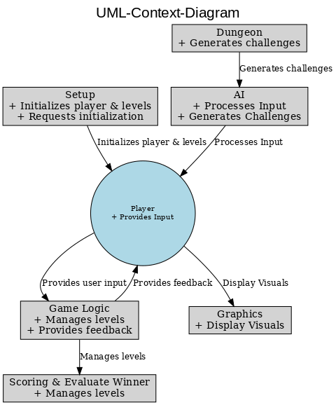

4. Systems Requirements

4.1 “Setup” Requirements
Requirement Title: | Setup
Sequence No: | 001
Short description: | Create player instance
Description: | - The system must create a new player instance when a new game session begins.  - The player must be initialized with default values:  - Health = 100  - Coins = 0  - Equipped items = none  - The player instance must exist before any gameplay logic can be executed.  - This setup is necessary to ensure that GameLogic, Dungeon, and Scoring can access valid player data.
Pre-Conditions: | - The user initiates a new session.
Post Conditions: | - A Player object is created in memory with default attributes.
Other attributes: | - Prepares for future support of saved game state.

Requirement Title: | Setup
Sequence No: | 002
Short description: | Initialize Game Environment
Description: | The system must initialize all required components to prepare for gameplay.  - The following components must be instantiated and ready:  - Game Logic  - Artificial Intelligence  - Dungeon  - Scoring System  - The system must set the current level to 1 and preload Dungeon level 1 using its default settings.
Pre-Conditions: | - Player object has been successfully created and initialized.
Post Conditions: | - All core game components exist in memory and are ready to interact.  - Dungeon level 1 is configured for play.
Other attributes: | - The system links these components so they can share game state and logic.

Requirement Title: | Setup
Sequence No: | 003
Short description: | Display Start Screen
Description: | - The system must display the start screen using the Graphics component after setup is complete.  - The screen must include 3 options that user interacts with:  - Enter Dungeon  - Enter Shop  - Exit Game  - This visual display must not appear until all components are fully initialized.  - The start screen provides confirmation to the player that the game is ready to begin.
Pre-Conditions: | - All core systems (Player, GameLogic, Dungeon, etc.) have been successfully initialized.
Post Conditions: | - A start interface is visible on screen.  - The player can now interact and proceed into gameplay.  - process player choice (of 3 options)
Other attributes: | The Exit Game is directly handled by this component. If the player chooses to exit in the main menu, the setup will close the game.

Requirement Title: | Setup
Sequence No: | 004
Short description: | Enter Shop and Display Upgrade Options
Description: | - The system must allow the player to enter the in-game shop from the main screen.  - Once inside the shop, the system must display two categories:  - Weapons  - Shields  - After selecting a category, the system must display three purchasable items per category, each with a visible coin cost. ( signal to screen visuals component depending on user choice)  This setup gives the player the opportunity to upgrade before entering a dungeon level.
Pre-Conditions: | - Player selects “Shop” from the main menu.
Post Conditions: | - The player is shown item categories and can select one to browse items.
Other attributes: | N/A

Requirement Title: | Setup
Sequence No: | 005
Short description: | Validate Purchase Attempt and Deliver Item
Description: | The system must verify that the player has enough coins before finalizing a purchase.  If the player does not have enough coins:  - The system must deny the transaction  - Display a message informing the player that more coins are required  - Return the player to the shop selection menu  If the player has enough coins:  - Deduct the coin amount  - Add the item to the player’s inventory  - Display a success message
Pre-Conditions: | - Player has selected an item and attempted to make a purchase.
Post Conditions: | - The player either receives the item or is returned to the shop with feedback.  - Return back to main menu
Other attributes: | This logic applies equally to both weapons and shields.

Requirement Title: | Setup
Sequence No: | 006
Short description: | Enter Dungeon
Description: | - Signal to Screen Visuals to display the dungeon levels  - Selections from here on out are handled strictly with dungeon ex: level 1,2,3,and 4  - This decision is passed to GameLogic, Dungeon and then to Graphics for UI display.
Pre-Conditions: | - All components have been initialized and running for input
Post Conditions: | - Notify dungeon and game logic that the player has selected to enter the dungeon.  - Dungeon, GameLogic, and Graphics get notified
Other attributes: | N/A

4.2 “Graphics” Requirements

Requirement Title: | Graphics
Sequence No: | 001
Short description: | Render game objects and scenes
Description: | - Manages the drawing and rendering of all visual elements within the game, including player, enemies, backgrounds, and UI components  - Ensures smooth transitions and animations during gameplay.  - Utilizes a graphics pipeline for rendering.
Pre-Conditions: | - Graphics must be properly configured.  - All game objects and scenes must be available for rendering.
Post Conditions: | - Visual elements are rendered and displayed accurately on the screen.  - Rendering processes are completed within time limits to maintain performance.
Other attributes: | N/A

Requirement Title: | Graphics
Sequence No: | 002
Short description: | Manage UI elements and menus
Description: | - Handles UI components such as health bars, scores, menus, and game over screens.  - Ensures smooth transitions and updates of UI elements.  - Manages different UI states such as Main Menu, Game Over Screen, and In-game UI  - Supports dynamic UI updates based on game events such as health updates.  - The manager provides:  -UI update  -Menu display  -Game over screen display
Pre-Conditions: | - GameRenderer must be actively rendering.  - Necessary UI components must be initialized and accessible.
Post Conditions: | - UI components are updated and displayed correctly.  - Continuous contact with GameLogic and Dungeon at all times.  - Player interactions with UI elements are accurately processed.
Other attributes: | Maintain a clean and responsive UI design.

Requirement Title: | Graphics
Sequence No: | 003
Short description: | Manage sprite resources
Description: | - Handles various sprite formats such as PNG, JPG, BMP, and GIF.  - The manager provides:  -Loading sprites from specified file paths.  -Retrieving sprites for rendering  -Updating sprite  -Removing unused sprites from memory
Pre-Conditions: | - Sprite must be available in the designated resource directory.  - Valid file paths must be provided for loading and retrieving sprites.
Post Conditions: | - Memory management is handled efficiently to prevent leaks.  - Sprites that are requested should be successfully loaded, updated, or removed as necessary.
Other attributes: | Maintain a clean and responsive UI design.

4.3 “Artificial Intelligence” Requirements

Requirement Title: | Artificial Intelligence
Sequence No: | 001
Short description: | Level 1 → Single-digit addition/subtraction
Description: | - Upon signaling of the Dungeon component, AI will generate questions for level 1. These include questions consisting of single-digit addition and subtraction  - ex: 5 + 3 - 4  - Questions will be randomly generated by the artificial intelligence  - Share the answer of the question with Scoring and Evaluate Winner component
Pre-Conditions: | - The player must select Level 1 before generating questions.  - Dungeon must signal to Artificial Intelligence to begin question generation process
Post Conditions: | - Questions should be presented to the player.  - Player responses are evaluated, and feedback is provided by the scoring and evaluate winner
Other attributes: | N/A

Requirement Title: | Artificial Intelligence
Sequence No: | 002
Short description: | Level 2 → Basic multiplication
Description: | - Upon signaling of the Dungeon component, AI will generate questions for level 2. These include questions consisting of basic multiplication  - ex: 5 x 3 x 4  - Questions will be randomly generated by the artificial intelligence  - Share the answer of the question with Scoring and Evaluate Winner component
Pre-Conditions: | - The player must unlock level 2 by completing level 1  - The player must select level 2  - Dungeon must signal to Artificial Intelligence to begin question generation
Post Conditions: | - Questions should be presented to the player.  - Player responses are evaluated, and feedback is provided by the scoring and evaluate winner
Other attributes: | N/A

Requirement Title: | Artificial Intelligence
Sequence No: | 003
Short description: | Level 3 → Exponents or two-step equations
Description: | - Upon signaling of the Dungeon component, AI will generate questions for level 3. These include questions consisting of single-digit addition and subtraction  - ex: 5^1, 5^3, 5^4  - Questions will be randomly generated by the artificial intelligence  - Share the answer of the question with Scoring and Evaluate Winner component
Pre-Conditions: | - The player must unlock level 3 by completing level 2  - The player must select level 3  - Dungeon must signal to Artificial Intelligence to begin question generation
Post Conditions: | - Questions should be presented to the player.  - Player responses are evaluated, and feedback is provided by the scoring and evaluate winner
Other attributes: | N/A

Requirement Title: | Artificial Intelligence
Sequence No: | 004
Short description: | Level 4 → Complex equation multi-step boss challenge
Description: | - AI will generate complex, multi-step problems that require several calculations  - ex : (2 -3) * 5 =  - Questions will be randomly generated by the artificial intelligence  - Share the answer of the question with the Scoring and Evaluate Winner component.
Pre-Conditions: | - The player must unlock level 4 by completing level 3  - The player must select level 4  - Dungeon must signal to Artificial Intelligence to begin question generation
Post Conditions: | - Questions should be presented to the player.  - Player responses are evaluated, and feedback is provided by the scoring and evaluate winner
Other attributes: | N/A

4.4 “Dungeon” Requirements

Requirement Title: | Dungeon
Sequence No: | 001
Short description: | Enter Dungeon Menu
Description: | - The system must display the dungeon selection interface when the player chooses to enter the dungeon phase from the main menu.  - The interface must show available levels in a visually distinct manner (e.g., tiles or buttons), allowing players to view which levels are unlocked or locked.  - This requirement ensures that players engage with the dungeon system through a guided and consistent flow, and sets the stage for level-specific configuration.  - The dungeon menu must remain inaccessible if the Setup component is incomplete or improperly initialized.
Pre-Conditions: | - The player has completed setup and reached the main selection screen.  - The player selects the “Enter Dungeon” option.
Post Conditions: | - The dungeon menu is rendered on screen.  - The player can choose from the available unlocked levels.
Other attributes: | The system may include visual indicators (e.g., level numbers, icons, or progress bars) for better clarity.

Requirement Title: | Dungeon
Sequence No: | 002
Short description: | Restrict Access to Locked Levels
Description: | - The system must prevent players from accessing any dungeon level that they have not yet unlocked through prior completion.  - This is enforced by comparing the player’s completed level count against the selected level number.  - Locked levels must be disabled or visually grayed out in the dungeon menu. If the player tries to select one, a feedback message must explain why access is denied (e.g., “Complete Level 2 to unlock this!”).  - This requirement maintains intended gameplay pacing, increases challenge progression, and prevents sequence breaking.
Pre-Conditions: | - The player has opened the dungeon menu.
Post Conditions: | - Only levels that have been unlocked are selectable  - Any attempt to access locked levels is blocked and followed by feedback.  - level completion is shared with the setup to update the start screen upon successfully winning a level.
Other attributes: | upon level completion, levels with unlock at setup

Requirement Title: | Dungeon
Sequence No: | 003
Short description: | Display Dungeon-Level Visuals
Description: | - The system must instruct the Graphics component to load and display the appropriate visuals for the selected dungeon level.  - The monsters HP increases as the levels increase  - This requirement enhances difficulty. More questions need to be answered and the player must do so accurately. Player has a limited amount of time to get questions wrong.  - The visuals must be displayed before challenge generation and remain visible throughout the level attempt.
Pre-Conditions: | - The player has selected an unlocked level from the dungeon menu.
Post Conditions: | - The Graphics component displays the level’s visual environment.  - The UI prepares to render challenge content next.
Other attributes: | May also include animations (enemy entrance), music, or stage labels

Requirement Title: | Dungeon
Sequence No: | 004
Short description: | Generate Level-Specific Challenge
Description: | Once a level has been selected and visuals loaded, the system must request the AI component to generate a math challenge tailored to the level’s difficulty.  Signal to AI to select a problem type based on the level:  Level 1 → Single-digit addition/subtraction  Level 2 → Basic multiplication  Level 3 → Exponents or two-step equations  Level 4 → Composite multi-step boss challenge  This requirement ensures that the learning content scales with the player's progression and supports the game’s educational goals.
Pre-Conditions: | - Visuals for the level have been displayed.  - The player has not yet submitted an answer.
Post Conditions: | - A challenge is displayed in the UI.  - The correct answer is stored internally for later evaluation.
Other attributes: | N/A

Requirement Title: | Dungeon
Sequence No: | 005
Short description: | Reset Dungeon on Player Failure
Description: | If a player fails a challenge (e.g., incorrect answer and health reaches zero), the system must reset the dungeon level to its initial state.  This reset includes:  - Re-initializing the math challenge  - Resetting enemy health  - Clearing input fields and previous attempt data  - player cannot proceed to next level if level failure  - This ensures that players have a consistent and fair retry experience, free from any leftover logic or UI artifacts.
Pre-Conditions: | - Player has failed a challenge and is eligible to retry.
Post Conditions: | - Dungeon state is restored to original conditions.  - Player can attempt the level again from the beginning.
Other attributes: | N/A

Requirement Title: | Dungeon
Sequence No: | 006
Short description: | Handle Completions of Dungeon Level
Description: | The system must properly handle all game state updates and transitions after a player successfully completes a dungeon level.  Upon successful completion (i.e., correct answer and enemy health reaches zero), the system must:  - Mark the current level as completed by updating counter  - Return the player to the main menu or dungeon menu  - Enable the next level in the dungeon menu (unlocking progression)
Pre-Conditions: | - Player has answered correctly and defeated the dungeon boss/challenge.
Post Conditions: | - Current level is marked complete.  - Next level is unlocked.  - Player is returned to a neutral state (e.g., main menu or dungeon menu).
Other attributes: | May include victory animations, sound effects, or coin reward triggers.  Transition screen or success feedback should be shown before returning to the menu.

4.5 “Game Logic” Requirements

Requirement Title: | Game Logic
Sequence No: | 001
Short description: | Start Game Session
Description: | - The system must begin the game session by initializing the GameLogic loop.  - The GameLogic component must access references to all active components (Player, Boss, Dungeon, AI, ScoringSystem).  - It must coordinate these components to prepare for gameplay and transition from setup to the first turn.  - This serves as the main entry point of the system once Setup is complete.
Pre-Conditions: | - Setup has completed.  - All components have been initialized.
Post Conditions: | - GameLogic is in control of the main game flow.  - The first math challenge is generated and displayed.
Other attributes: | Called immediately after the player clicks chooses selected level

Requirement Title: | Game Logic
Sequence No: | 002
Short description: | Evaluate Answer and Apply Effects
Description: | - Time constraint: there will be a limited amount of time for the player to respond. If the player can not respond in time, they automatically lose health.  - The system must send the player’s answer to the Scoring & Evaluate Winner System for validation. (This is done if the player answers before the time runs out)  - If correct, GameLogic must reduce the boss’s health and award coins.  - If incorrect, the boss must attack and reduce the player’s health.  - GameLogic does not calculate the result but ensures the appropriate components are triggered and updated.
Pre-Conditions: | - Player input has been received and stored.
Post Conditions: | - Player or boss health is reduced.
Other attributes: | Also responsible for triggering UI updates and animations via Graphics.

Requirement Title: | Game Logic
Sequence No: | 003
Short description: | Manage Turn Sequence
Description: | - The system must execute the primary loop of gameplay where the player and boss interact through math challenges.  - This includes requesting a question from AI, waiting for user input, and passing the result to the ScoringSystem.  - The GameLogic component is responsible for controlling when turns start and end, and who is affected by each result.  - consistently remain in contact with screen visuals to maintain the sequence of fight screens displayed
Pre-Conditions: | - Player has entered an active level.  - Dungeon and AI are ready.
Post Conditions: | - A full turn has been processed (question → input → result → state update).  - Control remains with GameLogic for the next round.
Other attributes: | - Repeat until the win/loss condition is met.

Requirement Title: | Game Logic
Sequence No: | 004
Short description: | Check Win/Loss Conditions
Description: | - After each answer, the system must check whether either the player or boss has reached 0 health.  - If the boss is defeated, GameLogic must trigger level progression via Dungeon.  - If the player is defeated, the game must end and pass control to Graphics to render the game-over screen.  - Reward will be given based on outcome. No coins will be taken away on a loss. Coins will be rewarded on a win.
Pre-Conditions: | - At Least 1 turn has been completed.  - Health values may have changed.
Post Conditions: | - Game continues if both players are alive.  - Game ends or advances based on result.
Other attributes: | This check runs automatically after every turn sequence.

Requirement Title: | Game Logic
Sequence No: | 005
Short description: | Advance to Next Level
Description: | - If the boss is defeated, GameLogic must increment the level and signal the Dungeon to update the current challenge.  - A new boss instance is created, and a new math problem is generated using increased difficulty.  - The system must reset temporary state values while preserving persistent data like player coins and upgrades.
Pre-Conditions: | - Boss health has reached zero.  - Game is not over.
Post Conditions: | - Levels completed are incremented. Next level has been unlocked  - Prepare the system for the next level and loop through the beginning of the sequence of requirements.
Other attributes: | Coin multipliers may increase based on level.

4.6 “Scoring & Evaluate Winner” Requirements

Requirement Title: | Scoring and Evaluate Winner
Sequence No: | 001
Short description: | Validate Player Answer
Description: | - The system must compare the player’s answer to the correct answer and return a Boolean result to GameLogic.  - The scoring system must receive both values from GameLogic and must not accept any inputs that are non-numeric or undefined.  - This ensures that only clean, intentional player inputs are passed to damage calculation.
Pre-Conditions: | - Player answers and correct answers have been passed to Scoring by GameLogic.
Post Conditions: | - A true/false value is returned to GameLogic indicating answer correctness.
Other attributes: | N/A

Requirement Title: | Scoring and Evaluate Winner
Sequence No: | 002
Short description: | Calculate and Return Answer Result
Description: | - The system must determine whether the submitted player answer is correct by comparing it to the correct answer.  - ScoringSystem must return a Boolean result to GameLogic indicating correctness.  - GameLogic is responsible for deciding who receives damage and for triggering the result.
Pre-Conditions: | - GameLogic has received an answer from the player.
Post Conditions: | - A true/false result is returned to GameLogic.  - GameLogic determines whether the player or boss is damaged based on the result.
Other attributes: | Supports scalable grading logic (e.g., difficulty adjustments).

Requirement Title: | Scoring and Evaluate Winner
Sequence No: | 003
Short description: | Reward Player with Coins
Description: | The system must reward the player with a certain number of coins when their answer is correct.  The amount of coins awarded is influenced by factors such as:  - The difficulty level of the question  - The current dungeon level  - The score multiplier stored in the ScoringSystem  This supports long-term progression and enables purchases in the shop.
Pre-Conditions: | - The player has won the level
Post Conditions: | - Player’s coin balance is increased.  - Score multiplier may be updated internally.
Other attributes: | May be used to unlock special upgrades or bonus content.

Requirement Title: | Scoring and Evaluate Winner
Sequence No: | 004
Short description: | Declare Win or Loss
Description: | - The system must determine whether the game has ended based on the health of the player and the boss.  - If the player’s health is reduced to 0, the system must declare a loss.  - If the boss is defeated and there are no more levels (optional), the system must declare a win.  - This decision is passed to GameLogic and then to Graphics for UI display.
Pre-Conditions: | - Health values have been updated by GameLogic.
Post Conditions: | - Game state is flagged as “won,” “lost,” or “in progress.”  - GameLogic reacts accordingly (e.g., ending session or advancing level).
Other attributes: | May interface with future features like leaderboards or score history.

5. Software Processes and UML Diagrams

5.1 Hardware and Infrastructure
As of now there will be no issues, the website will be compatible with all web browsers.

5.2 UML Diagrams
5.2.1 UML-ActivityDiagram-Setup

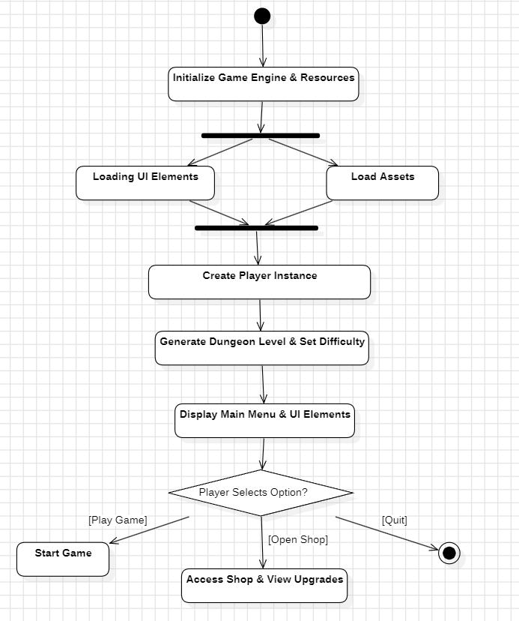
5.2.2 UML-ClassDiagram-Graphics

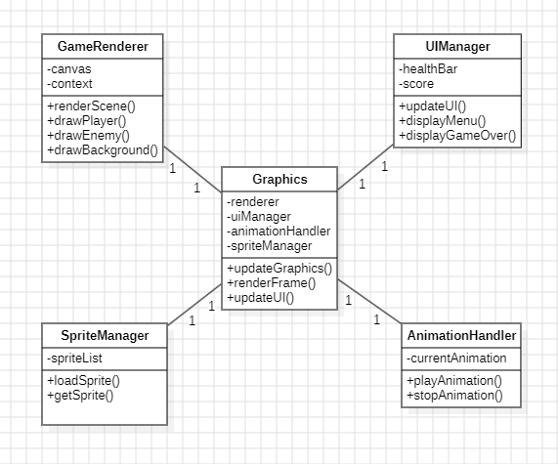

5.2.3 UML-StateTransitionDiagram-AI

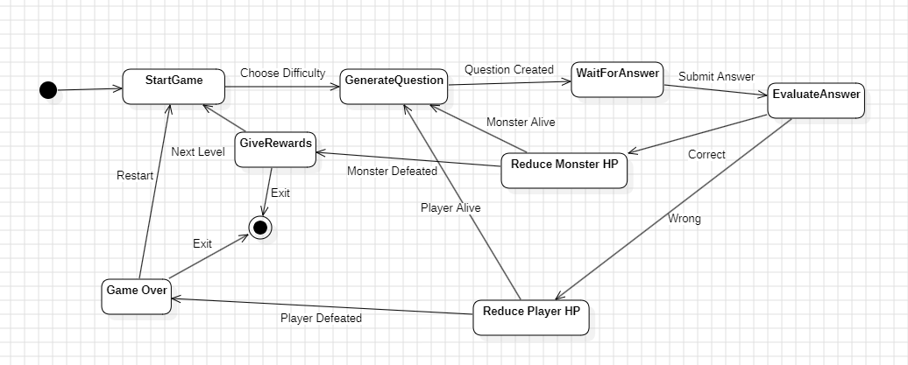

5.2.4 UML-SequenceDiagram-Dungeon

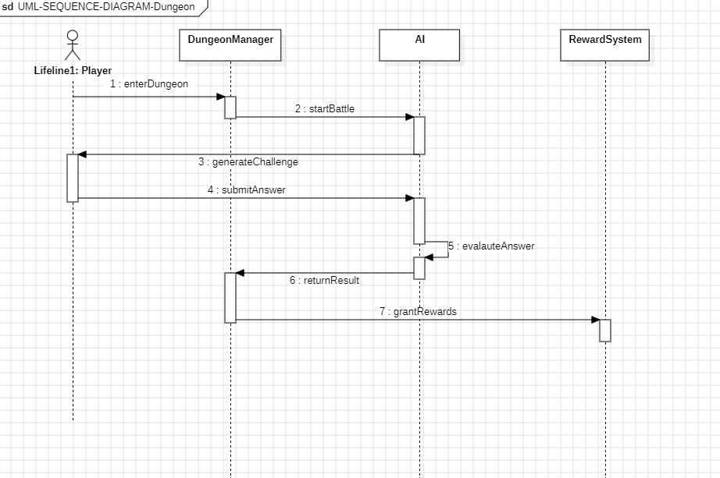

5.2.5 UML-ClassDiagram-GameLogic

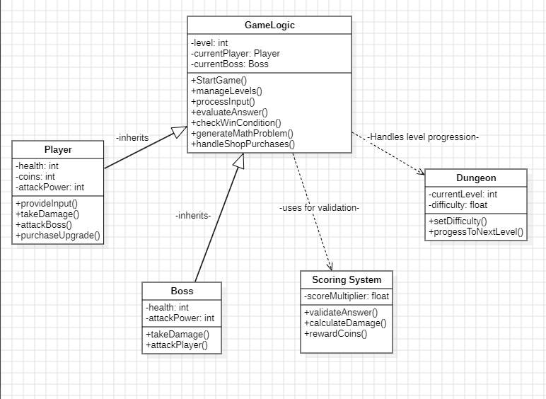

5.2.6 UML-SequenceDiagram-Scoring&EvaluatingWinner
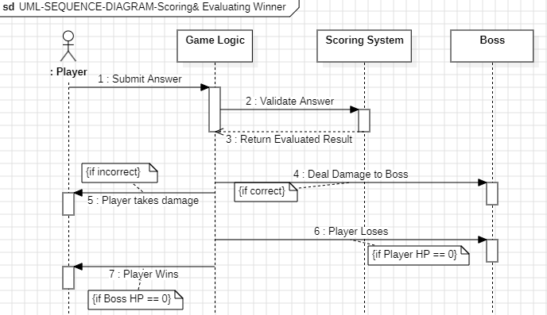

5.3 Test Plan:

5.3.1 Test Cases: “Setup”

Project Name: Bunny Wars Game
Test Case Name: Setup
Test Case Id: CSE3310/Spring 2025/Team8/Setup

Test Case No. | Test Case Description | Expected results | Outcome  Pass, Fail, Other (comments)
TC1 | Open Website in browser | The system should display the information below:  - Bunny Wars introduction description  - Bunny Wars visuals  - Main Menu  - Enter Shop  - Enter Dungeon  - Exit
TC2 | Enter the shop, then choose weapons, and try to make a purchase at the start of the game. | - Weapon Shop visuals must be displayed  - The system should provide an error message that tells the user that they do not have enough coins and may go to the dungeon to get some.
TC3 | Enter the Dungeon at the beginning of the game | Only level 1 should be visible.
TC4 | Choose dungeon level 1 and win the level (playerhealth>0 and boss/monster health <= 0) . | - coins should be granted  - upon the first attempt of playing a level, you will be rewarded 50 coins  - the shop will not allow any purchase less than 100 coins
TC5 | After winning dungeon level 1, enter the dungeon again. | - level 1 and 2 should now be visible.  - the player may not progress until all previous levels have been finished.
T6 | After winning dungeon level 2, make a purchase in the weapons shop that is worth 100 coins | - purchase should be made successfully  - the player coins must be adjusted to a new count after purchase  - system should return to the main menu after purchase

5.3.2 Test Cases: “Graphics”

Project Name: Bunny Wars Game
Test Case Name: Graphics
Test Case Id: CSE3310/Spring 2025/Team8/Graphics

Test Case No. | Test Case Description | Expected results | Outcome  Pass, Fail, Other (comments)
TC1 | Open the game | - Start menu appears with “Start Game” button  - Visual elements are positioned correctly
TC2 | Enter the dungeon | Visual elements (background, player, enemies, UI) should be displayed properly
TC3 | Select a dungeon level and begin game | - Current math challenge is shown clearly  - Input field is visible  - player bunny visible  - monster bunny visible
TC4 | Exit dungeon and return to main menu | - Dungeon visuals are removed  -Main Menu is displayed
TC5 | Enter the shop screen from main menu | -Weapons and coin count are displayed  -All buttons are visible and interactable
TC6 | Battle against enemies(solve the questions) | Health Bar updates visually
TC7 | Answer a question incorrectly inside dungeon level 2 | - Boss sprite flashes, shakes, or plays animation  - Player receives visual feedback
TC8 | Answer a question correctly inside dungeon level 2 | - Player sprite shows damage effect  - Feedback text is displayed
TC9 | Lose all player health | -Show “Game Over” screen  -Buttons like “Restart” or “Exit” are visible
TC10 | Defeat enemies | -Show “Victory” screen  -Coins are rewarded visually

5.3.3 Test Cases: “Artificial Intelligence”

Project Name: Bunny Wars Game
Test Case Name: Artificial Intelligence
Test Case Id: CSE3310/Spring 2025/Team8/Artificial-Intelligence

Test Case No. | Test Case Description | Expected results | Outcome  Pass, Fail, Other (comments)
TC1 | Enter dungeon level one and test to see easy-level math problem at level 1 | - AI returns a basic problem (e.g., single-digit addition/subtraction)  - Difficulty corresponds to level
TC2 | Enter dungeon level 3 to see a medium-level problem at level 3 | - Problem includes multiple operations or two-digit numbers  - AI reflects increased difficulty
TC3 | Enter dungeon level 4 to see a hard-level problem | - AI returns complex problem (e.g., (3+4) *5)  - Problem difficulty matches high level
TC4 | AI receives an invalid level number | - AI returns fallback/default problem or throws handled error  - Game does not crash
TC5 | Request multiple questions in a row | - AI returns a different and valid problem each time  - No repeated or identical problems
TC6 | AI problem includes a correct and solvable answer | - AI returns a math question with a valid solution  - Answer can be programmatically verified
TC7 | AI response time under 1 second | - AI responds quickly to all problem requests  - Gameplay is not interrupted
TC8 | Verify question format is always valid (e.g., no syntax errors) | - AI never returns malformed expressions  - Output is readable and consistent
TC9 | AI adapts difficulty as level increases | - Internal scaling or logic clearly increases problem complexity as player progresses
TC10 | AI works consistently across all supported levels | - AI generates appropriate questions from beginning to end-game levels

5.3.4 Test Cases: “Dungeon”

Project Name: Bunny Wars Game
Test Case Name: Dungeon
Test Case Id: CSE3310/Spring 2025/Team8/Dungeon

Test Case No. | Test Case Description | Expected results | Outcome  Pass, Fail, Other (comments)
TC1 | Load dungeon at start of game | - Dungeon Level 1 is initialized  - Difficulty is set to base value (e.g., 1.0)  - Boss object is created with correct health and damage
TC2 | Re-enter the dungeon after completing level 1 | - Level 2 is now accessible  - Player may no longer replay level 1 unless feature is enabled  - Boss and question update to match level 2 settings
TC3 | Attempt to enter a level that has not been unlocked yet | - System prevents access  - Error or locked message is displayed  - No level data is loaded
TC4 | Defeat boss and progress to next dungeon level | - Dungeon level is incremented  - New boss is generated with increased difficulty  - AI scaling is triggered
TC5 | Dungeon difficulty increases each level | - Difficulty multiplier increases appropriately (e.g., +0.2 per level)  - Boss becomes harder  - Questions become more complex
TC6 | Check if Boss is reloaded with updated stats at a new level. Do this by completing level 1, and then starting level 2 | - Boss health, damage, and appearance scale with difficulty  - Previous boss instance is discarded
TC7 | Progress to final dungeon level and defeat boss | - Game ends with final level victory  - No new dungeon level is loaded  - End-game state is triggered
TC8 | Restart current dungeon level after a loss | - Boss is re-initialized  - Difficulty remains constant for that level  - Player starts over from beginning of that level
TC9 | Attempt to skip levels via URL manipulation or manual trigger (edge case) | - System rejects unauthorized access  - Player cannot load unearned levels  - Forced return to main menu or error screen

5.3.5 Test Cases: “Game Logic”

Project Name: Bunny Wars Game
Test Case Name: Game Logic
Test Case Id: CSE3310/Spring 2025/Team8/Game-Logic

Test Case No. | Test Case Description | Expected results | Outcome  Pass, Fail, Other (comments)
TC1 | Start a new game session from the main menu | - GameLogic instance is initialized  - References to Player, Dungeon, AI, and ScoringSystem are established  - First question is generated
TC2 | Begin turn sequence at level 1 | - GameLogic sends a request to AI for a question  - A question is displayed to the player  - Game waits for input
TC3 | Submit a valid answer to a question | - Answer is passed to ScoringSystem  - GameLogic receives true/false result  - Turn processing begins
TC4 | Submit an invalid (non-numeric or blank) answer | - GameLogic rejects the input  - Error is displayed  - Turn does not advance
TC5 |  | - Boss takes damage  - Player receives coins  - Health and coin state are updated
  Player answers correctly
TC6 | Player answers incorrectly | - Player takes damage  - No coins are rewarded  - Game continues to next turn
TC7 | Boss HP reaches 0 after player answers correctly | - GameLogic triggers win state for current level  - Dungeon progresses to next level  - Boss is reset
TC8 | Player HP reaches 0 after answering incorrectly | - GameLogic triggers game over  - End screen is displayed  - Level does not advance
TC9 | Restart a level after a loss | - GameLogic resets boss and question  - Player health is reset or maintained (based on design)  - New challenge is generated
TC10 | Complete a level and begin next level successfully | - Level count increases  - New boss is created  - Question difficulty increases  - Coins and upgrades persist

5.3.6 Test Cases: “Scoring & Evaluating Winner”

Project Name: Bunny Wars Game
Test Case Name: Scoring & Evaluating Winner
Test Case Id: CSE3310/Spring 2025/Team8/Scoring&Evaluating-Winner

Test Case No. | Test Case Description | Expected results | Outcome  Pass, Fail, Other (comments)
TC1 | Submit a correct answer during a dungeon level | - Scoring system returns true for correct answer  - Boss takes damage  - Player is awarded 50 coins
TC2 | Submit an incorrect answer during a dungeon level | - Scoring system returns false for incorrect answer  - Player takes damage  - No coins are awarded
TC3 | Defeat the boss (boss health <= 0) while player is still alive | - Boss is defeated  - Player wins the level  - Level increases  - Result is passed to Graphics for display
TC4 | Player is defeated (player health <= 0) before boss is defeated | - Player loses the game  - Game over screen is triggered  - No level progression occurs  - No coins are rewarded
TC5 | Win a level after failing it once before | - Player still receives 50 coins upon first successful completion  - Boss is reset after win  - Level may be replayable
TC6 | Defeat boss on last available level (end of game) | - Player receives win state  - Game ends with victory screen  - No additional levels appear in the dungeon
TC7 | Player attempts to answer after game over | -system should not allow for this to occur  -must return back to start menu
TC8 | Submit a mathematically correct answer in the wrong format (e.g., “08” instead of “8”) | - System recognizes the answer as valid  - No penalty is applied  - Answer is trimmed and compared correctly

5.4 Screen Shots
No screenshots available at this time.

6. Assumptions and Constraints

6.1 ASSUMPTIONS
The following is a list of assumptions:
- People of all ages can play this game
- The game will run smoothly on modern browsers (e.g., Chrome, Firefox, Safari) without requiring high-end hardware.
- Visuals will be lightweight to ensure fast loading times and smooth gameplay.
- The game will focus on basic math skills (e.g., addition, subtraction, multiplication, exponents) that are appropriate for the target audience.
- The difficulty of math problems will increase gradually to provide a learning curve.

6.2 CONSTRAINTS
The following is a list of constraints:
- Team lacks all coding skills
- if the page is refreshed, data for that game will be lost. (similar to other non login based games like slither.io, solitaire, etc)
- group mates quit, 3 people working on the project

6.3 OUT OF SCOPE MATERIAL
The following is a list of “out of scope” material:
- Post Project maintenance is not covered
- Advanced graphics. are not a priority for the initial release.The focus is on gameplay and educational value rather than cutting-edge visuals.
- While the game includes basic AI for generating math questions and boss behavior, advanced AI (e.g., adaptive difficulty, learning player behavior) is not a priority. The focus is on providing a consistent and fair challenge for players.

7. Delivery and Schedule

Task/Milestone Description | Anticipated Start Date | Anticipated End Date | Status | Comments
Prepare UML diagrams | 9/14/2025 | 3/18/2025 | Complete | UML diagram delivered  Increment 1 Deliverable
SRA document (Includes project objectives, Requirements, and UML diagrams) | 3/18/2025 | 4/3/2025 | In Progress | The deliverable will be the SRA document. By signing in section 8, all stakeholders agree on the content of the SRA.  Increment 2 Deliverable  - Ishana Khandakar will be submitting
Design: Design the big picture, define format, navigation, and functionality to include | 3/18/2025 | 3/28/2025 | To Be Completed (TBC) | Ishana Khandakar
Implementation: Web Design | 3/18/2025 | 3/27/2025 | Completed | Ishana Khandakar
Create Requirement List for Setup | 3/18/2025 | 4/3/2025 | Completed | Ishana Khandakar
Create Requirement List for Graphics | 3/18/2025 | 4/3/2025 | Completed | Seongmok Lee
Create Requirement List for Artificial Intelligence | 3/18/2025 | 4/3/2025 | Completed | Seongmok Lee
Create Requirement List for Dungeon | 3/18/2025 | 4/3/2025 | Completed | Ishana Khandakar
Create Requirement List for Game Logic | 3/18/2025 | 4/3/2025 | Completed | Jaafar Alumary
Create Requirement List for Scoring & Evaluate Winner | 3/18/2025 | 4/3/2025 | Completed | Jaafar Alumary
Implementation: Setup Requirements | 3/18/2025 | 3/27/2025 | Completed | Ishana Khandakar
Implementation Graphics Requirements | 3/21/2025 | 3/31/2025 | Completed | Ishana Khandakar
Implementation: Artificial Intelligence Requirements | 3/21/2025 | 3/31/2025 | Completed | Ishana Khandakar
Implementation: Dungeon Requirements | 3/18/2025 | 3/27/2025 | Completed | Ishana Khandakar
Implementation: Game Logic Requirements | 3/18/2025 | 3/27/2025 | Completed | Ishana Khandakar
Scoring & Evaluate Winner Requirements | 3/18/2025 | 3/27/2025 | Completed | Ishana Khandakar
Test case design | 10/26/2025 | 11/15/2025 | Completed | Increment 3 Deliverable
External Documentation (i.e. User Manual) | 11/16/2025 | 12/4/2025 | Completed
Project presentation | 4/25/2025 | 5/2/2025 | Completed
Final Milestone: project delivery |  | 5/2/2025 | Completed | Increment 4 Deliverable

8. Stakeholder Approval Form

Stakeholder Name | Stakeholder Role | Stakeholder Comments | Stakeholder Approval Signature and Date
Bahram Khalili | Development Mgr.
Aidan Gennuso | Project Assistant
Ishana Khandakar | Executive Coder, Developer, and Designer
Seongmok Lee | Developer
Jaafar Alumary | Developer

Appendix:

None

